
Activity based
Project Report on
Business Intelligence
C2P2 Project Module - I
Submitted to Vishwakarma University, Pune
Under the Initiative of
Contemporary Curriculum, Pedagogy, and Practice (C2P2)
By
Samrudhi Katariya
SRN No : 202202074
Roll No : 14
Div : F
Third Year Engineering

Faculty In-charge:- Prof. Tareek Pattewar
Date of Project 1: - 28/03/25

Department of Computer Engineering
Faculty of Science and Technology

Academic Year
2024-2025 Term-II

Business Intelligence: Project I
Project Name: Higher Education Student Performance Dashboard

Phase I-
Problem Statement:
Higher education institutions face challenges in monitoring student performance, attendance, and engagement levels. Identifying at-risk students early and implementing timely intervention strategies can improve academic success rates. This project aims to develop a Power BI dashboard that provides insights into student performance based on multiple data parameters such as:
- Academic Scores: Exam scores, GPA, subject-wise performance.
- Attendance Records: Percentage of classes attended.
- Engagement Metrics: Assignments submitted, participation in discussions, and LMS activity.
The dashboard will help educators and administrators take data-driven decisions to enhance student success.

Introduction:
In modern education, data analytics plays a crucial role in understanding student behavior, predicting performance trends, and improving overall academic outcomes. Many institutions struggle with manual tracking of student records, making it difficult to provide personalized guidance to students who need additional support.
With Power BI, we can:
- Analyze historical and real-time data.
- Identify patterns and trends in student behavior.
- Provide interactive visual reports to faculty and administrators.
This project will serve as a decision-support tool for institutions to enhance their academic strategies.

Related Study:

Several studies have demonstrated the importance of data-driven decision-making in education:
- UCI Machine Learning Repository Study: This study analyzed student performance using machine learning models applied to academic records. The research highlighted the correlation between attendance, study habits, and final grades, demonstrating how predictive analytics can help identify at-risk students.
- Harvard University Research on Online Learning: Harvard University conducted a study on student engagement in online courses. By analyzing LMS (Learning Management System) data, they identified key factors contributing to student dropouts and recommended personalized interventions based on participation metrics.
- Power BI in Universities: Many universities, such as MIT and Stanford, use Power BI dashboards to track student retention rates, attendance patterns, and academic success. Implementing real-time analytics has helped these institutions provide early intervention and improve student outcomes.
- World Bank Report on Education Analytics: The World Bank emphasized the role of data-driven decision-making in improving education policies worldwide. Countries that implemented student performance dashboards reported a significant improvement in graduation rates and academic achievements.
These studies highlight the growing need for business intelligence tools in the education sector and validate the significance of our project.

Flowchart
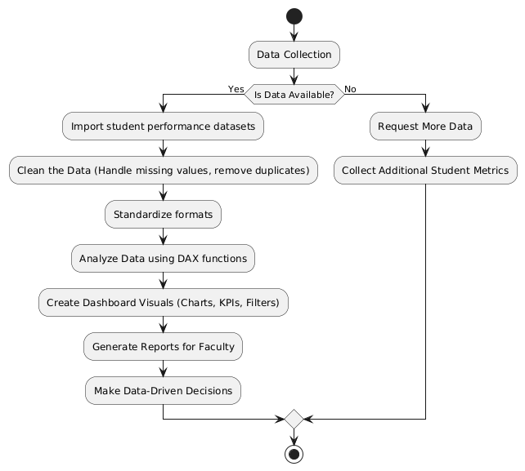
- Data Collection: Import student performance datasets from Kaggle or university records.
- Data Cleaning: Handle missing values, remove duplicates, and standardize formats.
- Data Analysis: Use Power BI's DAX functions to derive insights.
- Dashboard Development: Create interactive charts, KPIs, and filters.
- Decision Making: Generate reports for faculty to act on insights.
- Data Collection: Import student performance datasets from Kaggle or university records.
- Data Cleaning: Handle missing values, remove duplicates, and standardize formats.
- Data Analysis: Use Power BI's DAX functions to derive insights.
- Dashboard Development: Create interactive charts, KPIs, and filters.
- Decision Making: Generate reports for faculty to act on insights.
- Data Collection: Import student performance datasets from Kaggle or university records.
- Data Cleaning: Handle missing values, remove duplicates, and standardize formats.
- Data Analysis: Use Power BI's DAX functions to derive insights.
- Dashboard Development: Create interactive charts, KPIs, and filters.
- Decision Making: Generate reports for faculty to act on insights.

Algorithm
Step 1: Import datasets (Student Info, Performance, Attendance, Engagement).
Step 2: Clean the data (remove null values, standardize formats).
Step 3: Establish relationships between tables in Power BI.
Step 4: Create DAX measures for GPA, attendance rates, and engagement scores.
Step 5: Design visuals (bar charts, pie charts, tables, and trend lines).
Step 6: Apply filters for real-time analysis (by department, course, student level).
Step 7: Publish and share the dashboard with stakeholders.

Mathematical Model (if applicable)
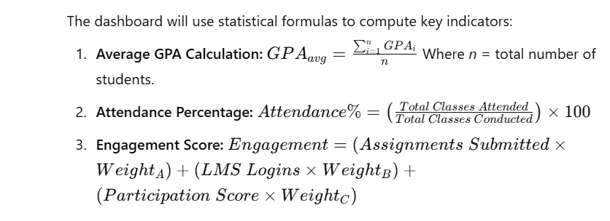

Project Design- Architecture block diagram with description
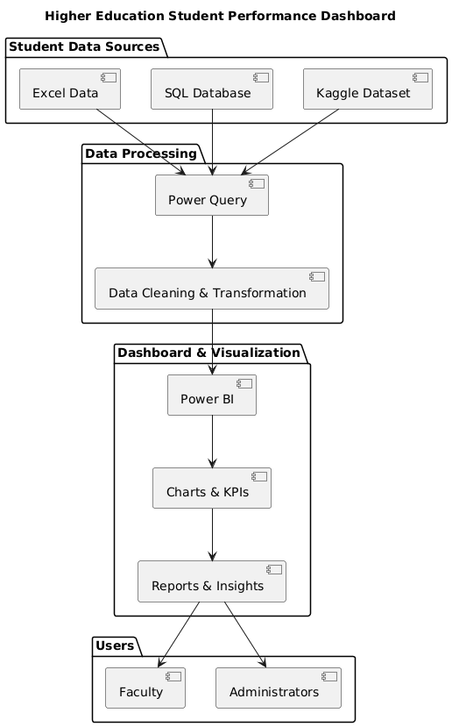
DASHBOARD:
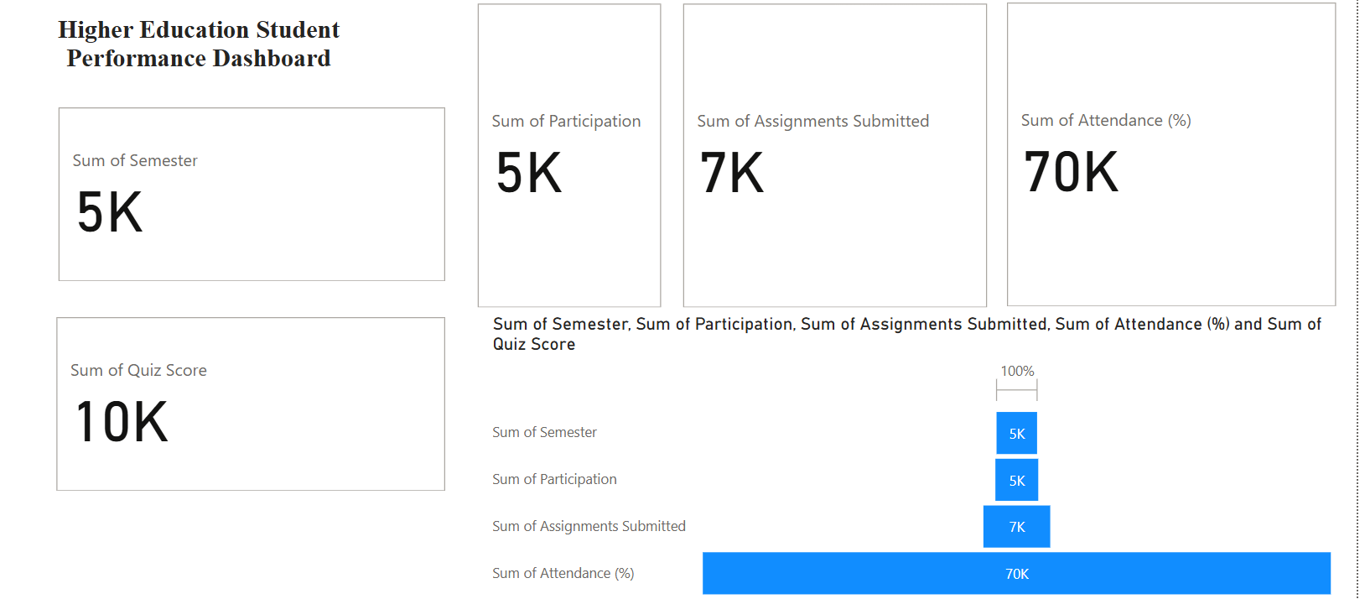
Key Performance Metrics (Displayed in Large Cards)
- Sum of Semester: 5K
  - Represents the total semester-related performance measure (e.g., total grades, credit hours, or student count).
- Sum of Participation: 5K
  - Measures the level of student participation (e.g., class discussions, activities, or engagement levels).
- Sum of Assignments Submitted: 7K
  - Indicates the total number of assignments submitted by students.
- Sum of Attendance (%): 70K
  - Shows the cumulative attendance percentage across students.
- Sum of Quiz Score: 10K
  - Represents the total quiz scores achieved by students.

• The stacked bar chart at the bottom visually represents the contribution of different metrics.
• Attendance (%) is the largest component (70K), meaning attendance is a significant factor in student performance.
• Assignments Submitted (7K) follows, suggesting students are actively engaging in coursework.
• Participation and Semester Scores (5K each) show balanced contributions.
• Quiz Score (10K) indicates student performance in quizzes.

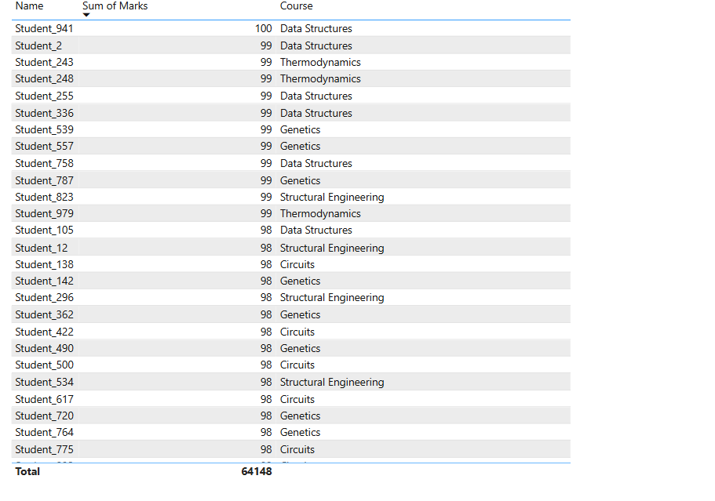
Bar Chart (Student-wise Marks)

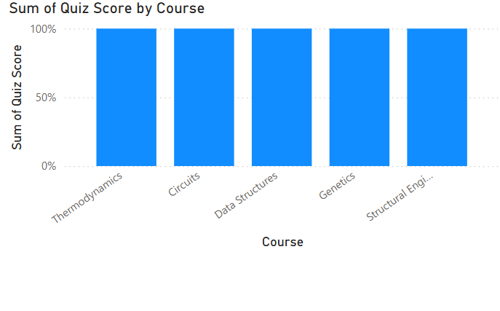
• Quick Comparison: Helps identify if students are performing consistently across all subjects or if there are any gaps.
• Identifying Weak Areas: If one subject had a lower bar, it would indicate students scored less in that course, signaling a need for improvement.
• Performance Analysis: Useful for teachers and students to assess quiz results across different subjects and maintain balanced learning progress.
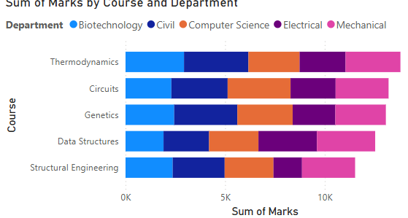
"Sum of Marks by Course and Department"
- Purpose: This chart shows the total marks obtained in different courses, categorized by department.
- X-Axis: Sum of Marks
- Y-Axis: Courses (Thermodynamics, Circuits, Genetics, Data Structures, Structural Engineering)
- Color Representation: Different colors represent different departments (Biotechnology, Civil, Computer Science, Electrical, Mechanical).
- Insights:
  - Each course is contributed to by multiple departments.
  - Marks distribution varies across courses and departments.
  - Some departments contribute more marks in specific courses.

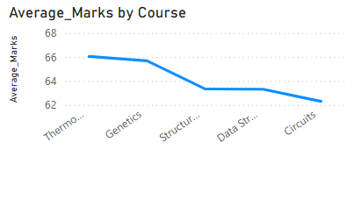

"Average Marks by Course"
- Purpose: This chart shows the trend of average marks across different courses.
- X-Axis: Course Names (Thermodynamics, Genetics, Structural Engineering, Data Structures, Circuits)
- Y-Axis: Average Marks
- Insights:
  - The highest average marks are in Thermodynamics (66 marks).
  - The lowest average marks are in Circuits (~62 marks).
  - There is a downward trend in average marks as we move from Thermodynamics to Circuits, showing a decrease in performance in later courses.

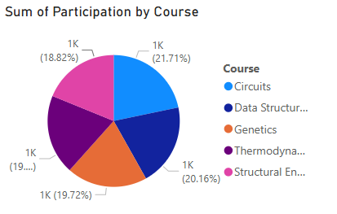
Sum of Participation by Course"
- Purpose: This chart displays the percentage distribution of student participation across different courses.
- Legend: Course Names (Circuits, Data Structures, Genetics, Thermodynamics, Structural Engineering)
- Insights:
  - Participation is nearly evenly distributed across courses.
  - Circuits have the highest participation (21.71%), followed by Structural Engineering (20.16%).
  - All courses have participation percentages in a close range (~18-22%), indicating balanced student engagement.
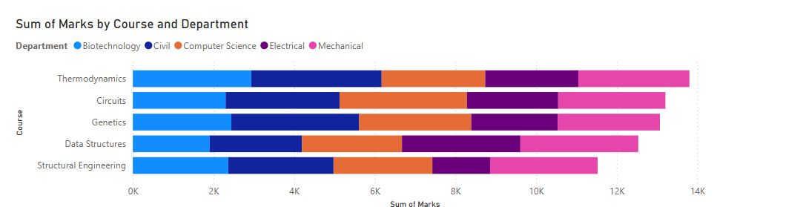

- X-axis: Sum of Marks (Total marks obtained in each course).
- Y-axis: Courses (Subjects like Thermodynamics, Circuits, Genetics, Data Structures, etc.).
- Color Representation: Different departments (Biotechnology, Civil, Computer Science, Electrical, and Mechanical).
- Insight:
  - This chart shows the distribution of marks across different courses and departments.
  - For example, Mechanical and Computer Science students appear to have higher marks in Structural Engineering than students from other departments.
  - The variation in colors within a bar indicates how different departments contribute to the total marks for each course.
- 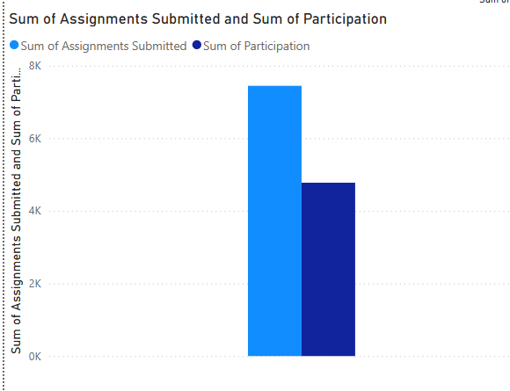

- X-axis: Category (Assignments Submitted vs Participation).
- Y-axis: Total count.
- Legend:
  - Light Blue: Number of assignments submitted.
  - Dark Blue: Number of participation instances.
- Insight:
  - The number of assignments submitted is significantly higher than the participation count.
  - This could indicate that students are more focused on assignment completion rather than active participation in discussions or projects.
  - The gap suggests an area for improvement in engagement and interaction.

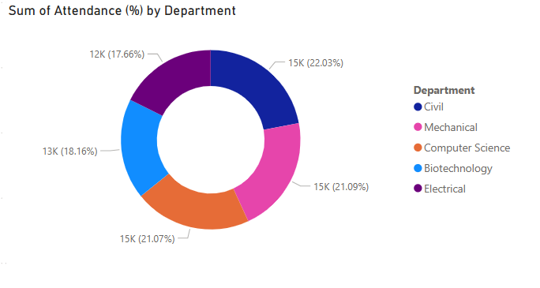
- Sections: Different departments (Civil, Mechanical, Computer Science, Biotechnology, Electrical).
- Numbers inside the chart:
  - Represent the total attendance percentage contribution for each department.
- Insight:
  - The departments have relatively balanced attendance rates, ranging from 17% to 22%.
  - The Civil Engineering department has the highest attendance (22.03%), while Electrical Engineering has the lowest (17.66%).
  - The data suggests that most departments have similar attendance trends, but some departments may need intervention strategies to improve participation.

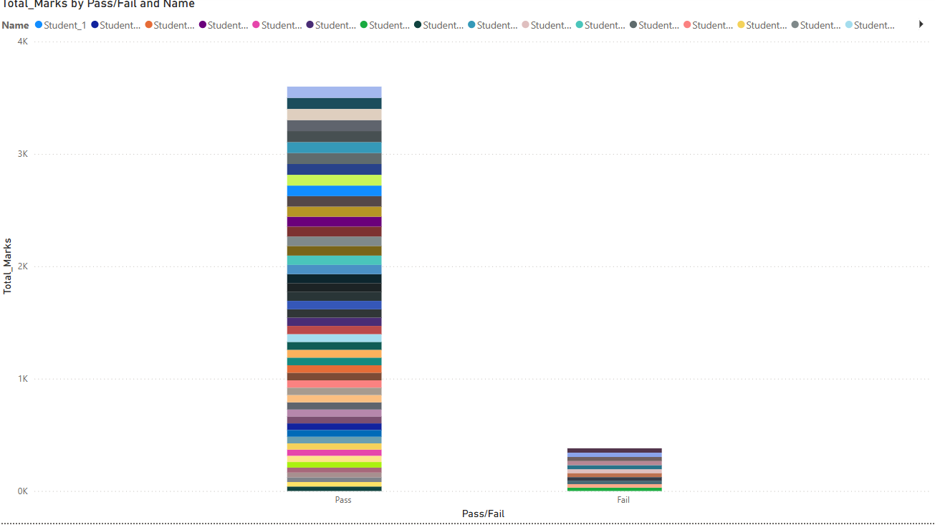

Chart Type: Stacked Bar Chart
X-Axis: Pass/Fail
- The two categories on the x-axis represent students who passed and students who failed.
Y-Axis: Total Marks
- This shows the cumulative marks of all students in each category (Pass/Fail).
Colors:
- Each color represents a different student.
- The legend at the top shows multiple students (e.g., Student_1, Student_2, etc.), but their names are truncated.
Insights from the Chart:
- Majority of Students Passed
  - The Pass bar is significantly taller than the Fail bar, meaning most students scored enough marks to pass.
- Few Students Failed
  - The Fail bar is much shorter, indicating fewer students had low scores.
- Varied Performance Among Pass Students
  - The Pass bar has multiple stacked colors, meaning students have different mark contributions.
  - Some students contributed more marks (larger sections in the stack), while others contributed less.
- Low Total Marks for Failed Students
  - The Fail category has smaller segments, showing that even the highest scorer in this category didn't get close to passing marks.

Project Insights
1. Objective
- The dashboard aims to analyze and visualize student performance metrics to support decision-making in higher education institutions.
- It helps identify academic trends, student strengths/weaknesses, and areas for institutional improvement.
2. Key Features of the Dashboard
- Student Performance Analysis: Track student scores, attendance, and overall academic progress.
- Course & Subject Insights: Identify high-performing and low-performing subjects/courses.
- Demographic Insights: Analyze student performance based on factors like gender, age, and location.
- Faculty Performance: Assess faculty efficiency based on student outcomes and feedback.
- Predictive Analysis: Use Power BI’s advanced analytics to predict student success and dropout risks.
3. Data Requirements
- Student details (ID, name, age, gender, course, department, year).
- Academic records (grades, attendance, assignments, exams).
- Faculty details (subject taught, feedback, student pass rate).
- Institutional details (departments, courses offered).
- External factors (scholarships, financial aid, extracurricular activities).
4. Power BI Features Used
- Data Cleaning & Transformation: Using Power Query to handle missing data and inconsistencies.
- DAX (Data Analysis Expressions): Creating custom calculations for performance metrics.
- Interactive Visuals: Line charts, bar graphs, heat maps, and KPIs to monitor student trends.
- Filters & Slicers: For drill-down analysis based on student, subject, and time periods.
- AI & Machine Learning: Implementing predictive analytics for early intervention on low-performing students.
5. Expected Outcomes
- Improved institutional decision-making based on real-time student insights.
- Early identification of students who need academic support.
- Enhanced course structures based on performance trends.
- Data-driven faculty evaluation and development.

Reference
- Kaggle Datasets:
  - Students Performance in Exams
  - Student Performance Data Set
- Power BI Documentation: https://learn.microsoft.com/en-us/power-bi/
- Research Papers on Student Analytics:
- https://scholar.google.com/citations?hl=en&user=fQ42U-8AAAAJ
- https://scholar.google.com/citations?hl=en&user=2kfLsLsAAAAJ

The Higher Education Student Performance Dashboard is a powerful tool for analyzing student academic data using Power BI. By integrating multiple data sources and leveraging data visualization techniques, institutions can make informed decisions to improve student success rates. This dashboard will enable faculty to identify at-risk students, monitor engagement levels, and enhance educational strategies. With further improvements, this model can be expanded to include predictive analytics for better academic planning and student support.

